Dummy row for customers (search surrogate key, if not, add) 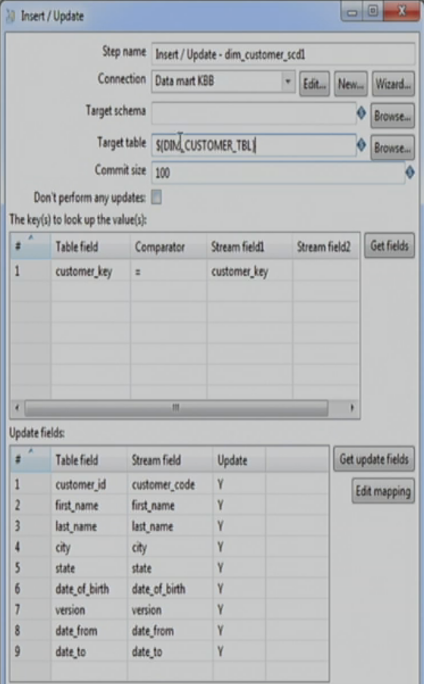

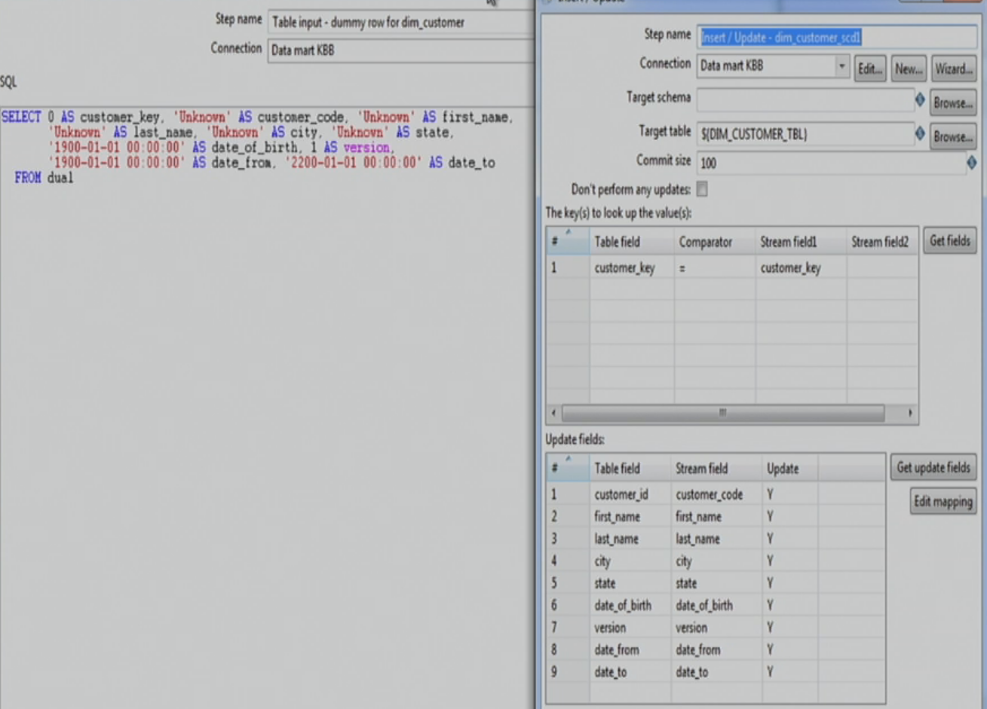

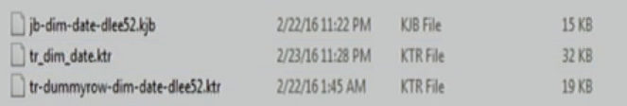

jb-dim-date-dlee52.kjb

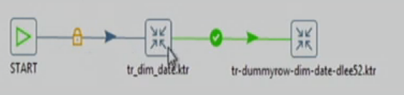

Tr-dummyrow-dim-date-dlee52.ktr

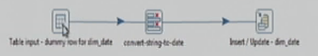

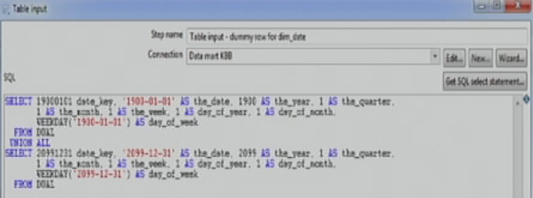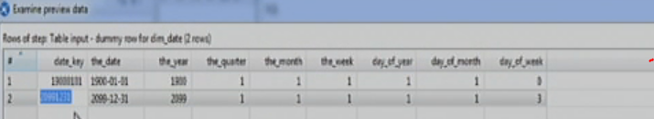

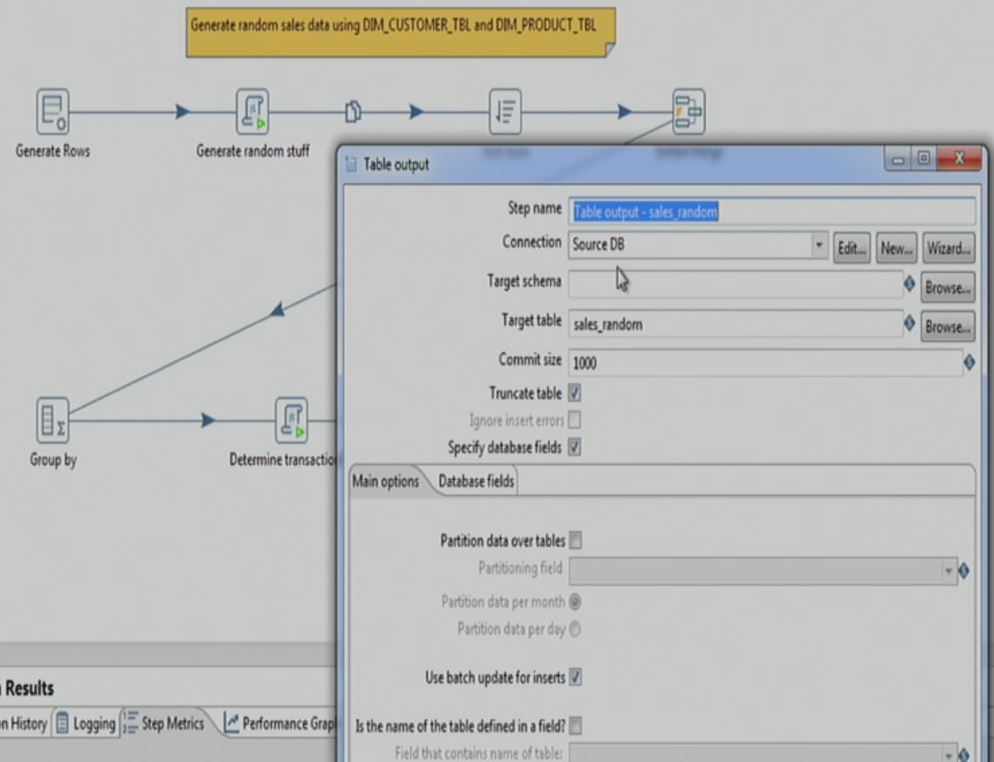

Jb-build-datamart-main-dlee52.kjb

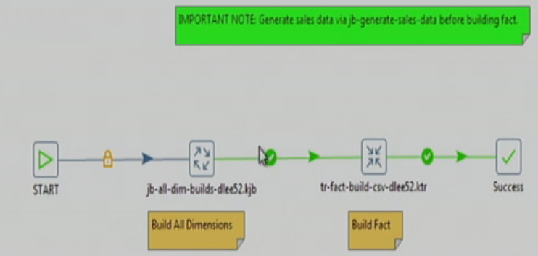

Jb-all-dim-builds-dlee52.kjb

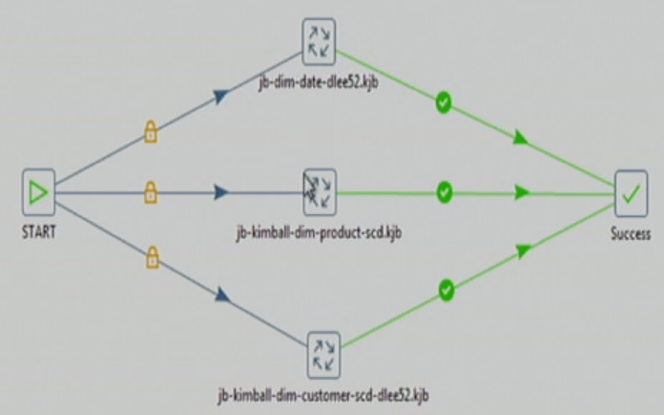

tr-fact-build-dlee52.ktr